**SRM Institute of Science and Technology**

**College of Engineering and Technology**

**B.Tech - Mechanical Engineering**

**Academic Year: 2022-23 Semester: 6 /Even Mark: 50**

**Subject Code: 18MEO113T Title: Design of Experiments Duration: 100 mins**

**Type of Test: CLA II**

| **Q. No.** | **Part A (10 x 1 = 10)** | **M** | **BL** | **CO** | **PO** | **PI** |
| --- | --- | --- | --- | --- | --- | --- |
| 1 | What information does the sign of the main effect provide?   1. direction of the effect 2. Strength of the effect 3. Magnitude of the effect 4. Interaction strength | 1 | 1 | 1 | 3 | 3.1.6 |
| 2 | Which of these steps are not conducted when the design of experiment procedure is adopted?   1. Determining which variable is most influential to output 2. Determining where to set the influential controllable factors so that output is near the nominal requirement 3. Deleting the uncontrollable factors 4. Determining where to set the influential controllable inputs so that the variability in the output is smallest | 1 | 2 | 1 | 3 | 3.1.6 |
| 3 | What kind of interaction is presented in this diagram?     1. Mutually exclusive 2. Cross over 3. Antagonistic 4. Synergistic | 1 | 1 | 1 | 3 | 4.1.4 |
| 4 | A formal way to seek the direction of maximum improvement in optimisation process problems is called the _____________.   1. Tunneling 2. Localisation 3. Method of steepest descent 4. Method of steepest ascent | 1 | 2 | 1 | 3 | 4.3.4 |
| 5 | What is the Hadamard matrix associated with?   1. Taguchi’s design 2. Screening Design 3. Confidence Level 4. Full-factorial design | 1 | 2 | 1 | 3 | 4.3.4 |
| 6 | Taguchi’s design makes __________ the focal point of his analysis.   1. Control Factors 2. Interactions 3. Blocking 4. Noise | 1 | 1 | 1 | 3 | 3.1.6 |
| 7 | Maximum permissible variations is called __________.   1. Loss 2. Quality 3. Tolerance 4. Function | 1 | 2 | 1 | 3 | 3.1.6 |
| 8 | In Orthogonal Array design of experiments, the inner array is for the design of ______.   1. Control Factors 2. Noise Factors 3. Random factors 4. Interactions | 1 | 1 | 1 | 3 | 4.3.4 |
| 9 | ___________ occurs when the effect of one factor on a response depends on the level of another factor(s).   1. Interaction 2. Error 3. Replication 4. Randomization | 1 | 2 | 1 | 3 | 4.3.4 |
| 10 | In 3σ quality performance, the probability of producing a conforming product is ________.   1. 0.99 2. 0.95 3. 1 4. 0.94 | 1 | 1 | 1 | 3 | 4.3.4 |
|  | | | | | | |
|  | **Part B - Answer any 2 out of 3 (2 x 4 = 8 marks)** |  |  |  |  |  |
| 11 | Give two differences between ‘Characterisation’ and ‘Optimisation’. | 4 | 2 | 2 | 3 | 3.1.6 |
| 12 | Write about this plot, key features and advantages. | 4 | 3 | 2 | 3 | 4.1.4 |
| 13 | Differentiate between geometric and non-geometric designs. | 4 | 3 | 2 | 3 | 4.1.4 |
|  | | | | | | |
|  | **Part C - Answer any 2 out of 3 (2 x 4 = 8 marks)** |  |  |  |  |  |
| 14 | Schematically represent Taguchi’s Terminology and state the response. | 4 | 3 | 2 | 3 | 4.3.4 |
| 15 | What is ‘Average Quality Loss’? | 4 | 2 | 2 | 3 | 4.3.4 |
| 16 | Which of the two processes is better, and what can you infer from the two processes? | 4 | 2 | 2 | 3 | 3.1.6 |
|  | | | | | | |
|  | **Part D - Answer either of the choices in each question. (2 x 12 = 24 marks)** |  |  |  |  |  |
| 17 | **A**. Write in detail about the steps in the practical methodology of DOE.  **OR**  **B.** Explain Pareto, NPP and cube plots with schematic examples. | 12 | 3  4 | 2  2 | 3  3 | 3.1.6  4.1.4 |
| 18 | **A.** Discuss Taguchi's loss function in detail.  **OR**  **B.** (i) Explain the categories of variability in input and output parameters in detail.  (ii) What is 'Interchangeability'? Explain with an example. | 12  8  +  4 | 3  4 | 3  3 | 2  2 | 3.1.6  4.3.4 |

**\*\*\*\*\*\***

**Prepared by: DSS**

**Outcome Alignment Matrix:**

| QUESTION  NUMBER | CO distribution | | | | |
| --- | --- | --- | --- | --- | --- |
| CO1 | CO2 | CO3 | CO4 | CO5 |
| 1 |  | x |  |  |  |
| 2 |  | x |  |  |  |
| 3 |  | x |  |  |  |
| 4 |  | x |  |  |  |
| 5 |  | x |  |  |  |
| 6 |  |  | x |  |  |
| 7 |  |  | x |  |  |
| 8 |  |  | x |  |  |
| 9 |  |  | x |  |  |
| 10 |  |  | x |  |  |
| 11 |  | x |  |  |  |
| 12 |  | x |  |  |  |
| 13 |  | x |  |  |  |
| 14 |  |  | x |  |  |
| 15 |  |  | x |  |  |
| 16 |  |  | x |  |  |
| 17A |  | x |  |  |  |
| 17B |  | x |  |  |  |
| 18A |  |  | x |  |  |
| 18B |  |  | x |  |  |
| **Total** |  |  |  |  |  |
| **%** |  | **50%** | **50%** |  |  |

“**Quality Matrix**”:

| **Question No.** | **BL Distribution** | | | |
| --- | --- | --- | --- | --- |
| **L1** | **L2** | **L3** | **L4** |
| 1 | x |  |  |  |
| 2 |  | x |  |  |
| 3 | x |  |  |  |
| 4 |  | x |  |  |
| 5 | x |  |  |  |
| 6 |  | x |  |  |
| 7 | x |  |  |  |
| 8 |  | x |  |  |
| 9 | x |  |  |  |
| 10 |  | x |  |  |
| 11 |  | x |  |  |
| 12 |  |  | x |  |
| 13 |  |  | x |  |
| 14 |  |  | x |  |
| 15 |  | x |  |  |
| 16 |  | x |  |  |
| 17A |  |  | x |  |
| 17B |  |  |  | x |
| 18A |  |  | x |  |
| 18B |  |  |  | x |
| **Total** |  |  |  |  |
| **%** |  |  |  |  |

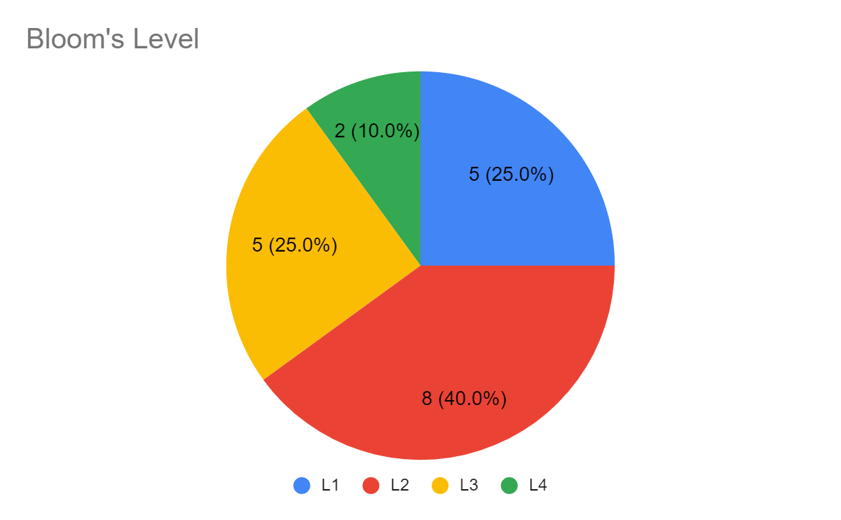

Prepared by and Course Coordinator

(Deborah Serenade Stephen)